Sexual Misconduct: Sexual Harassment, Sexual Assault, Stalking, & Relationship Violence
Resources and Referral Options

Medical Assistance  - Students can go to Palmetto Health Richland for medical services.  - A Sexual Assault Exam is available at Palmetto Health Richland Hospital. The exam is conducted by a Sexual Assault Nurse Examiner (SANE) who is a Registered Nurse with advanced training and certification in conducting sexual assault exams. There will be no charge for the evidence collection process.  - A police report is not required to receive medical assistance. | Advocacy, Support Services, Housing, & Academic Accommodations  - Counseling Services is a confidential source that provides individual counseling, referrals, crisis intervention, and consultation.  - Pathways to Healing is a confidential source that provides a  24-hour hotline, advocacy, and counseling.  - The Title IX Coordinator investigates and ensures Title IX Compliance and implementation of College policies and procedures. He/She can assist you with academic and housing accommodations, community resources, and referrals.
Emergency Services

- The Columbia College Police Department provides 24-hour emergency services.
- Students can also call 911 for 24-hour emergency services from the Columbia Police Department.
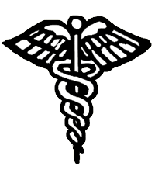
911
Housing or Academic Accommodations

Title IX Coordinator

Mrs. Julie King
803-786-3765
Business hours
803-786-3333
After Hours or Weekends
Medical Assistance

Palmetto Health Richland Hospital Emergency Room
803-434-7000
Emergency Services

On-Campus:
Columbia College Police Department
803-786-3333

Off-Campus:
City of Columbia Police Department
911
Advocacy & Support Services

Counseling Services
803-786-3603

Pathways to Healing
803-771-7273

